**Chat app** with Flutter and Firebase from scratch (include Firebase Auth, Google Sign-In, Cloud FireStore and Firebase Storage).

Features:

Sign-in by Google account.

Chat one to one with other users (send text, image, sticker).

Update profile and avatar.

First, if you would like to use Google sign-in, get SHA-1 key to use Google sign-in.

Step:

keytool -exportcert -v \-alias androiddebugkey -keystore %USERPROFILE%\.android\debug.keystore

keytool -list -v \-alias androiddebugkey -keystore %USERPROFILE%\.android\debug.keystore

Need to do 2 times because, 1 for exportcert and the other one for -list.

For ios, add this line #import <Firebase/Firebase.h> to AppDelegate.h

Start the Cloud Firestore and storage. Then enable google sign-in method.

For Firebase storage, use this rules:

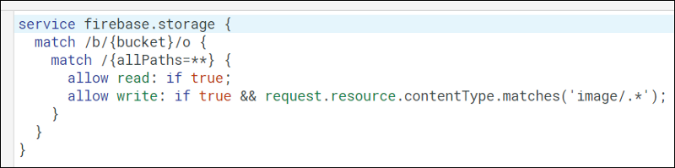

Use this mode for storage to accept only image file type.

The rule check image file type only works for Android (iOS always not match this condition even you upload the image). Because the image upload at Android is image/jpeg or image.png… but on iOS is just application/octet-stream no matter what the file type is.

So you can temporarily remove the second condition or change it to

if true && (request.resource.contentType.matches('image/.*') || request.resource.contentType.matches('application/octet-stream'));

Rules at Database:

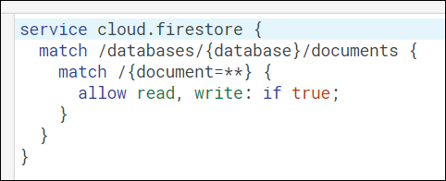

Don’t forget to add support email In firebase or else you will get google_sign_in error when run the application.

Reference: <https://medium.com/flutter-community/building-a-chat-app-with-flutter-and-firebase-from-scratch-9eaa7f41782e>

Github reference: <https://github.com/duytq94/flutter-chat-demo>